Red Clase C (W.X.Y.###)
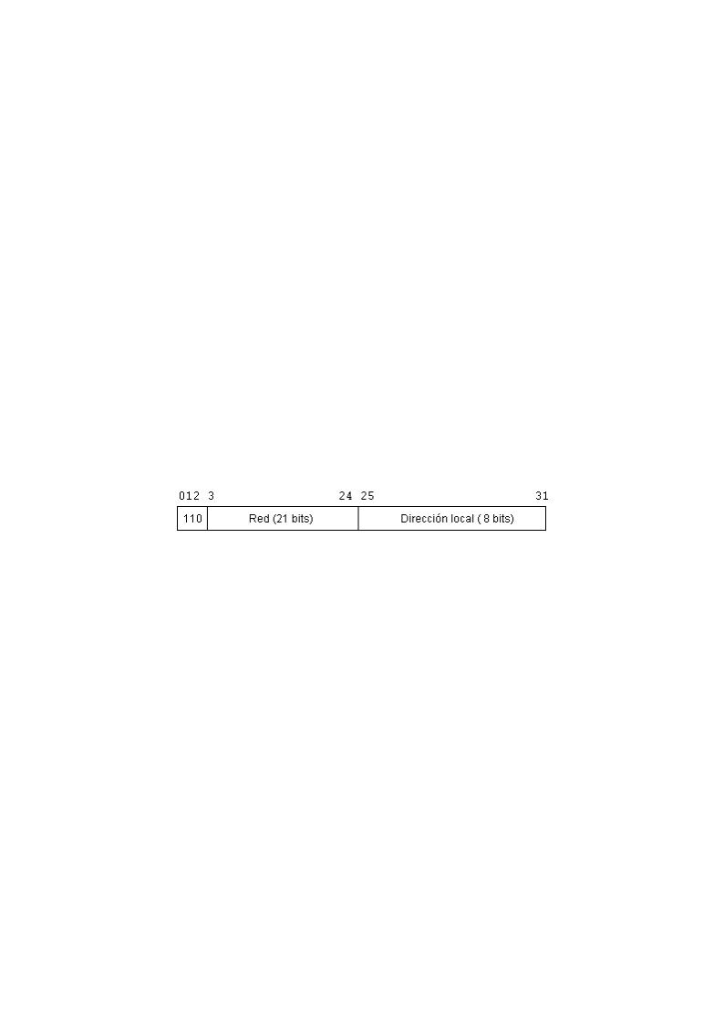
Máscara | Bits de Red | Bits de Host | Nº máximo de Redes  2bits de red | Nº máximo de Host  (2bits de host)-2
11111111.11111111.11111111.10000000  255.255.255.128 | 1 | 7 | 2 | 126
11111111.11111111.11111111.11000000  255.255.255.192 | 2 | 6 | 4 | 62
11111111.11111111.11111111.11100000  255.255.255.224 | 3 | 5 | 8 | 30
11111111.11111111.11111111.11110000  255.255.255.240 | 4 | 4 | 16 | 14
11111111.11111111.11111111.11111000  255.255.255.248 | 5 | 3 | 32 | 6
11111111.11111111.11111111.11111100  255.255.255.252 | 6 | 2 | 64 | 2

