Red clase B (W.X.###.###)
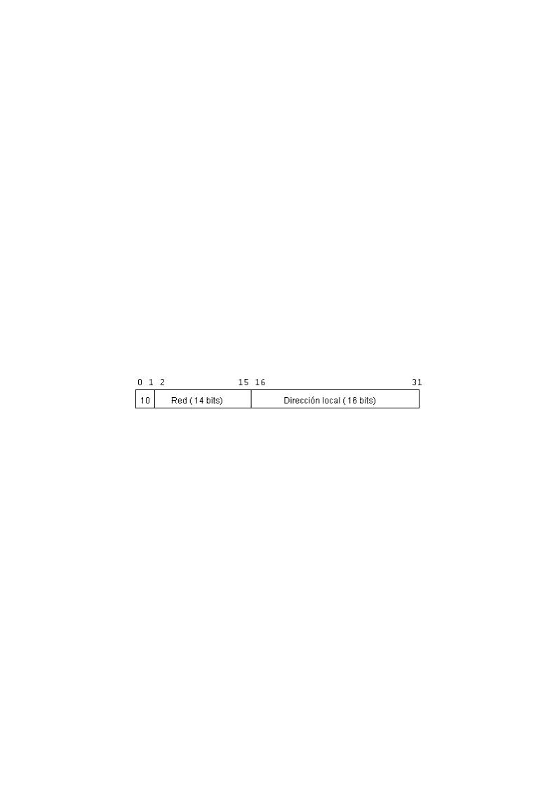
Máscara | Bits de Red | Bits de Host | Nº máximo de Redes  2bits de red | Nº máximo de Host  (2bits de host)-2
11111111.11111111.10000000.00000000  255.255.128.0 | 1 | 15 | 2 | 32.766
11111111.11111111.11000000.00000000  255.255.192.0 | 2 | 14 | 4 | 16.382
11111111.11111111.11100000.00000000  255.255.224.0 | 3 | 13 | 8 | 8.190
11111111.11111111.11110000.00000000  255.255.240.0 | 4 | 12 | 16 | 4094
11111111.11111111.11111000.00000000  255.255.248.0 | 5 | 11 | 32 | 2.046
11111111.11111111.11111100.00000000  255.255.252.0 | 6 | 10 | 64 | 1.022
11111111.11111111.11111110.00000000  255.255.254.0 | 7 | 9 | 128 | 510
11111111.11111111.11111111.00000000  255.255.255.0 | 8 | 8 | 256 | 254
11111111.11111111.11111111.10000000  255.255.255.128 | 9 | 7 | 512 | 126
11111111.11111111.11111111.11000000  255.255.255.192 | 10 | 6 | 1.024 | 62
11111111.11111111.11111111.11100000  255.255.255.224 | 11 | 5 | 2.048 | 30
11111111.11111111.11111111.11110000  255.255.255.240 | 12 | 4 | 4.096 | 14
11111111.11111111.11111111.11111000  255.255.255.248 | 13 | 3 | 8.192 | 6
11111111.11111111.11111111.11111100  255.255.255.252 | 14 | 2 | 16.384 | 2

