Red Clase A (W.###.###.###)
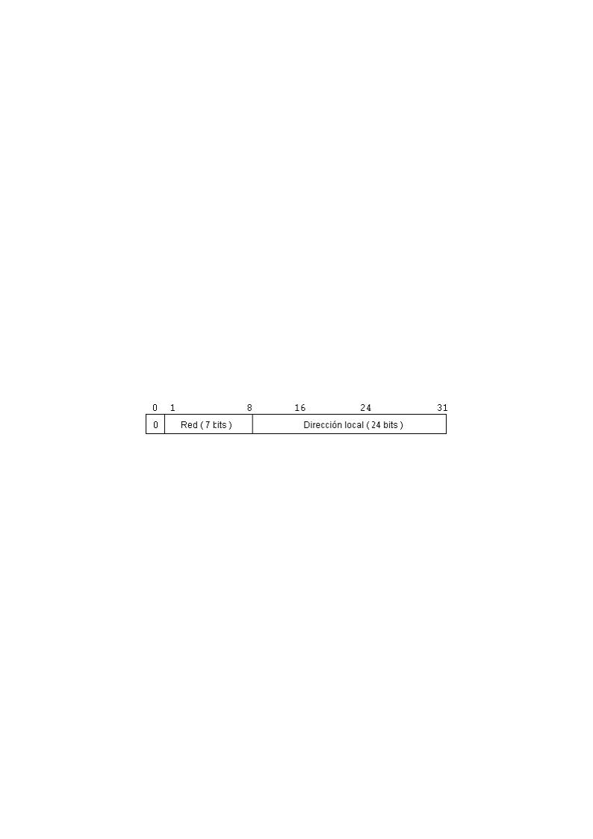
Mascara | Bits de Red | Bits de Host | Nº máximo de Redes | Nº máximo de Host
11111111.10000000.00000000.00000000  255.128.0.0 | 1 | 23 | 21=2 | 2<sup> 23-2</sup>= 8.388.604
11111111.11000000.00000000.00000000  255.192.0.0 | 2 | 22 | 22=4 | 222-2=4.194.302
11111111.11100000.00000000.00000000  255.224.0.0 | 3 | 21 | 23=8 | 221-2=2.097.150
11111111.11110000.00000000.00000000  255.240.0.0 | 4 | 20 | 24=16 | 220-2=1.048.574
11111111.11111000.00000000.00000000  255.248.0.0 | 5 | 19 | 25=32 | 219-2=524.286
11111111.11111100.00000000.00000000  255.252.0.0 | 6 | 18 | 26=64 | 218-2=162.142
11111111.11111110.00000000.00000000  255.254.0.0 | 7 | 17 | 27=128 | 217-2=131.070
11111111.11111111.00000000.00000000  255.255.0.0 | 8 | 16 | 28=256 | 216-2=65.534
11111111.11111111.10000000.00000000  255.255.128.0 | 9 | 15 | 29=512 | 215-2=32.766
11111111.11111111.11000000.00000000  255.255.192.0 | 10 | 14 | 210=1024 | 214-2=16.382
11111111.11111111.11100000.00000000  255.255.224.0 | 11 | 13 | 211=2048 | 213-2=8.190
11111111.11111111.11110000.00000000  255.255.240.0 | 12 | 12 | 212=4096 | 212-2=4094
11111111.11111111.11111000.00000000  255.255.248.0 | 13 | 11 | 213=8192 | 211-2=2046
11111111.11111111.11111100.00000000  255.255.252.0 | 14 | 10 | 214=16384 | 210-2=1022
11111111.11111111.11111110.00000000  255.255.254.0 | 15 | 9 | 215=32768 | 29-2=510
11111111.11111111.11111111.00000000  255.255.255.0 | 16 | 8 | 216=65536 | 28-2=254
11111111.11111111.11111111.10000000  255.255.255.128 | 17 | 7 | 217=131072 | 27-2=126
11111111.11111111.11111111.11000000  255.255.255.192 | 18 | 6 | 218=262144 | 26-2=62
11111111.11111111.11111111.11100000  255.255.255.224 | 19 | 5 | 219=524.288 | 25-2=30
11111111.11111111.11111111.11110000  255.255.255.240 | 20 | 4 | 220=1048576 | 24-2=14
11111111.11111111.11111111.11111000  255.255.255.248 | 21 | 3 | 221=2097152 | 23-2=6
11111111.11111111.11111111.11111100  255.255.255.252 | 22 | 12 | 222=4194304 | 22-2=2
Se quitan 2 al nº de hosts debido a que la dirección todo a 1 ó todo a 0 no son válidas ya que están reservadas.
Está tabla está confeccionada permitiendo el primer bit de subred (RFC 1878) .

